VidBrief: Youtube Transcript Summarizer


A
Project Report
Submitted in partial fulfillment of the requirement for the award of degree of
Bachelor of Technology
In
Computer Science &Engineering (Data Science)

Submitted to
RAJIV GANDHI PROUDYOGIKI VISHWAVIDYALAYA,
BHOPAL (M.P.)

Guided By: Submitted By:
Prof. Pawan Makhija Bhavya Jain (0827CD211018)

DEPARTMENT OF CSE(DS)
ACROPOLIS INSTITUTE OF TECHNOLOGY & RESEARCH,
INDORE (M.P.) 452020
2024-2025
Declaration
I hereby declare that the work, which is being presented in the project entitled VidBrief partial fulfillment of the requirement for the award of the degree of Bachelor of Technology, submitted in the department of Computer Science & Engineering (Data Science) at Acropolis Institute of Technology & Research, Indore is an authentic record of my own work carried under the supervision of “Prof. Pawan Makhija”. I have not submitted the matter embodied in this report for the award of any other degree.

Aditya Yadav (0827CD211005)
Akash Patel(0827CD211006)
Bhavya Jain (0827CD211018)
Neeraj Sahu (0827CD211040)

Prof. Pawan Makhija
Supervisor

Project Approval Form
I hereby recommend that the project VidBrief prepared under my supervision by Bhavya Jain (0827CD211018) be accepted in partial fulfillment of the requirement for the degree of Bachelor of Technology in Computer Science & Engineering (Data Science).

Prof. Pawan Makhija
Supervisor

Recommendation concurred in 2024-2025

Prof. Mayank Bhatt
Project Incharge

Prof. Deepak Singh Chouhan
Project Coordinator

Acropolis Institute of Technology & Research
Department of Computer Science & Engineering (Data Science)

Certificate
The project work entitled VidBrief submitted by Bhavya Jain (0827CD211018), is approved as partial fulfillment for the award of the degree of Bachelor of Technology in Computer Science & Engineering (Data Science) by Rajiv Gandhi Proudyogiki Vishwavidyalaya, Bhopal (M.P.).

Internal Examiner External Examiner
Name:………………. Name: ……………..
Date: …./…/……….. Date: …./…/………..

Acknowledgement

With boundless love and appreciation, we would like to extend our/my heartfelt gratitude and appreciation to the people who helped us/me to bring this work to reality. We/I would like to have some space of acknowledgement for them.
Foremost, we would like to express our sincere gratitude to our supervisor, Prof. Pawan Makhija whose expertise, consistent guidance, ample time spent and consistent advice that helped us/me to bring this study into success.
To the project in-charge Prof. Mayank Bhatt and project coordinator Prof. Deepak Singh Chouhan for their constructive comments, suggestions, and critiquing even in hardship.
To the honorable Prof. (Dr.) Prashant Lakkadwala, Head, Department of Computer Science & Engineering (Data Science) for his favorable responses regarding the study and providing necessary facilities.
To the honorable Dr. S.C. Sharma, Director, AITR, Indore for his unending support, advice and effort to make it possible.
Finally, we would like to pay my/our thanks to faculty members and staff of the Department of Computer Science & Engineering for their timely help and support.
We also like to pay thanks to our parents for their eternal love, support and prayers without them it is not possible.
Aditya Yadav (0827CD211005)
Akash Patel (0827CD211006)
Bhavya Jain (0827CD211018)
Neeraj Sahu (0827CD211040)

Abstract

With the rapid increase in online video content, platforms like YouTube have become major sources of information, entertainment, and education. This surge presents a challenge for users seeking concise information without watching lengthy videos. A YouTube transcript summarizer addresses this need by generating quick, accurate summaries from video transcripts, allowing users to grasp the core content efficiently. This project report details the development of a YouTube transcript summarizer tool, which automates the extraction, processing, and summarization of video transcripts to provide brief, coherent summaries.
The core objective of the project is to design a user-friendly tool that delivers accurate summaries by leveraging natural language processing (NLP) techniques. The summarization process involves several steps: transcript extraction, text preprocessing, summary generation, and evaluation. The tool begins by extracting the transcript directly from a YouTube video (either through API access or from closed-caption files). The transcript data, typically unstructured and verbose, undergoes preprocessing, including noise removal, sentence segmentation, and tokenization. This step prepares the text for efficient summarization, removing unnecessary words, fillers, and irrelevant content.
For summary generation, the project uses advanced NLP algorithms, focusing on extractive or abstractive summarization models. Extractive summarization selects key phrases or sentences from the transcript, presenting a summary using the original words. In contrast, abstractive summarization involves rephrasing and condensing content to create a summary that resembles human writing. Given the computational constraints and the goal of real-time performance, this project uses a hybrid approach that combines rule-based extraction with neural network-based models to generate summaries that are both concise and contextually relevant.
Additionally, the project addresses scalability by creating a modular architecture that can be adapted for various transcript formats and can potentially handle multilingual content. Future improvements include expanding the tool’s capabilities to support different languages, integrate sentiment analysis, and personalize summaries based on user preferences.
In conclusion, the YouTube transcript summarizer fulfills a pressing need in today’s digital age by providing efficient, accurate, and readable summaries of video content. This tool has implications for a broad range of users, from students and professionals seeking concise information to casual viewers looking to save time. By using GPU-accelerated NLP techniques, this project demonstrates how modern technology can address information overload, making vast amounts of online content more accessible and manageable.

Table of Content

Declaration.......................................................................................................pg. 2
Project Approval Form...................................................................................pg. 3
Acknowledgement...........................................................................................pg. 5
Abstract............................................................................................................pg. 6
List of Figures..................................................................................................pg. 11
Abbreviations...................................................................................................pg. 12
Chapter 1: Introduction.................................................................................pg. 13-19
1.1 Rationale..........................................................................................pg. 13
1.2 Existing System...............................................................................pg. 13
1.3 Problem Formulation.......................................................................pg. 14
1.4 Proposed Syste................................................................................pg. 15
1.5 Objectives........................................................................................pg. 16
1.6 Contribution of the Project..............................................................pg. 17
1.6.1 Market Potential...............................................................pg. 17
1.6.2 Innovativeness..................................................................pg. 17
1.7 Report Organization........................................................................pg. 19
Chapter 2: Requirement Engineering...........................................................pg. 20-24
2.1 Feasibility Study (Technical, Economical, Operational..................pg. 20
2.2 Requirement Collection...................................................................pg. 20
2.2.1 Requirement Analysis.......................................................pg. 20
2.3 Requirements...................................................................................pg. 21
2.3.1 Functional Requirements..................................................pg. 21
2.3.2 Nonfunctional Requirements.............................................pg. 22
2.4 Hardware & Software Requirements…………...............................pg. 23
2.4.1 Hardware Requirement (Developer & End User).............pg. 23
2.4.2 Software Requirement (Developer & End User)..............pg. 23
2.5 Use-case Diagram............................................................................pg. 23
2.5.1 Use-case Descriptions.......................................................pg. 24
Chapter 3: Analysis & Conceptual Design & Technical Architecture......pg. 25-30
3.1 Technical Architecture..............................................................pg. 25
3.2 Sequence Diagrams..................................................................pg. 26
3.3 Class Diagrams.........................................................................pg. 27
3.4 DFD..........................................................................................pg. 28
3.5 Data Design..............................................................................pg. 30
3.5.1 E-R Diagram....................................................................pg. 30
Chapter 4: Implementation & Testing….....................................................pg. 31-35
4.1 Methodology….........................................................................pg. 31
4.1.1 Proposed Algorithm.........................................................pg. 31
4.2 Implementation Approach........................................................pg. 32
4.2.1 Introduction to Languages, IDEs and Technologies.......pg. 32
4.3 Testing Approache.....................................................................pg. 34
4.3.1 Unit Testing.....................................................................pg. 34
4.3.2 Integration Testing..........................................................pg. 35
Chapter 5: Results & Discussion………………...........................................pg. 36-40
5.1 User Interface Representation........................................................pg. 36
5.2 Snapshot of System with Brief Description...................................pg. 36
5.3 Database Description......................................................................pg. 39
5.3.1 Snapshot of Database Tables with Brief Description…...pg. 39
5.4 Final Findings…………………………………………………..…pg. 40
6. Conclusion & Future Scope………………………………………………pg. 41-42
6.1 Conclusion……………………………………………....…..…….pg. 41
6.2 Future Scope……………………………………………..………..pg. 42
REFERENCES…………………………………………………...………....pg. 44
Appendix A: Project Synopsis
Appendix B: Guide Interaction Report (*Duly Signed by Guide)

List of Figures

1. Use Case diagram…………………………………………………………....pg. 24
2. Technical Architecture....................................................................................pg. 26
3. Sequence Diagram...........................................................................................pg. 27
4. Class Diagram……………………………………………………………….pg. 28
5. DFD (level-1)..………………………………………………………………pg. 29
6. DFD (level-2)..………………………………………………………………pg. 29
7. DFD (level-3)..………………………………………………………………pg. 30
8. E-R Diagram………………………………………………………………...pg. 30
9. User-Interface Representation……………………………………………….pg. 36
10. About Page………………………………………………………………....pg. 36
11. Login Page……………………………………………………………........pg. 37
12. Signup Page..................................................................................................pg. 37
13. User input page.............................................................................................pg. 38
14. Output page..................................................................................................pg. 38
15. Database tables.............................................................................................pg. 39

Abbreviations

1. AI: Artificial Intelligence
2. API: Application Programming Interface
3. CSS: Cascading Style Sheets
4. GUI: Graphical User Interface
5. HTML: Hyper Text Markup Language
6. IDE: Integrated Development Environment
7. ML: Machine Learning
8. NLP: Natural Language Processing
9. URL: Uniform Resource Locator

Chapter 1: Introduction

1.1 Rationale
A YouTube transcript summarization project is valuable for enhancing accessibility, efficiency, and knowledge extraction from the vast amount of content on the platform. With millions of hours of video uploaded every day, finding relevant information in lengthy videos is time-consuming for users. Summarizing transcripts enables quicker access to essential points, making it easier for audiences to decide if the content meets their needs without watching the entire video.
For content creators and researchers, transcript summaries offer a streamlined way to analyze video trends, themes, and insights across multiple videos. This can facilitate content planning and optimize engagement strategies based on popular topics or trends. Additionally, transcript summaries contribute to improved SEO, as search engines can index concise summaries to help users find videos relevant to specific queries.
Moreover, summarization improves accessibility for users with hearing impairments or non-native speakers, offering an easier way to consume information. With advances in natural language processing, automating transcript summarization can be efficient and scalable, providing succinct summaries in real-time or post-upload. Overall, a YouTube transcript summarization project serves as a beneficial tool for users, creators, and businesses alike, making YouTube content more accessible, discoverable, and user-friendly.
1.2 Existing Systems
1. HARPA AI: Struggles with accurately summarizing videos with complex or technical content. May miss nuances or context, leading to incomplete summaries.
2. Merlin AI: Can be resource-intensive, especially for long videos. Sometimes generates summaries that are too brief, missing key details.

3. Scrapestorm: Lacks real-time integration with YouTube, making the process tedious, and summarization quality is also inconsistent for longer videos.

4. Eightify: Can sometimes oversimplify content, leading to loss of important information. Also, it may not handle videos in languages other than English effectively.

5. Youtubesummarizer.tech: May struggle with videos that have poor audio quality or heavy accents, leading to inaccurate transcripts and summaries.
1.3 Problem Formulation
The primary goal is to summarise the whole transcript of the YouTube video so that the user can easily understand the crux without the need to dedicate much time while watching the video.
Constraints: The system must consider various constraints such as:
- Accuracy: Predictions must be reliable and precise.
- Timeliness: The system should generate summaries in a timely manner.
- Scalability: It should be capable of handling texts with a large token size.
- Cost-effectiveness: The solution should be economically viable for large scale use.
Inputs: The inputs for the system typically include:
- YouTube video URL: This is the URL of the video to be summarized.
The system will automatically fetch the transcript using the API and will generate the summary. The user will only need to enter the URL of the video he/she wants to summarise and the rest is done by the system.
Expected Outputs: The system should output:
- Summary: The summary of the video transcript corresponding to the provided URL in required word limit specified by the user.
1.4 Proposed System
The proposed solution for this project is a web-based application that will allow users to summarize the YouTube video transcipts.
The application will use a variety of libraries and frameworks, such as HTML, CSS, Python, Flask, MySQL, numpy, pandas, scikit-learn, tensorflow and NLP technologies like transformers for creating pipelines for summarization.
The application will also provide a user-friendly interface that will allow users to summarize the video by simply providing the URL of the corresponding video and the rest will be done by the system.
The system has the following abilities which are required by the user:
1. Reliability:
The model will have a high degree of reliability, ensuring that it produces accurate results consistently and with minimal downtime.

2. Availability:
The Forest Fire Prediction System will be available 24x7, providing all users with quick and easy access to summaries whenever needed.

3. Security:
The system will have robust security measures in place to protect data and prevent unauthorized access.

4. Maintainability:
The model will be easily maintainable, allowing for regular updates and improvements to be made to the system.

5. Portability:
The model will be portable, allowing it to run on various devices and platforms with an internet connection.

6. Integration with existing technologies:
The system will be designed to integrate with existing technologies and devices, such as smartphones, to provide users with a seamless experience.

1.5 Objectives
  - Main Objective:
Develop an automated system that generates concise, meaningful summaries of YouTube video transcripts. This will allow users to quickly grasp the core ideas of a video without watching it in full, saving time and aiding in content discovery.
  - Other Objectives:
- Enhanced Accessibility: Provide summaries that make video content more accessible to people with hearing impairments, non-native speakers, or users with limited time, enabling them to understand the video’s key points quickly.
- Direct YouTube API Integration: The tool will integrate directly with the YouTube API to automatically fetch video transcripts, eliminating the need for manual input or copy-pasting.
- Improved Content Discovery: Enable users to more easily find relevant videos by generating search-friendly summaries, enhancing search engine optimization (SEO) and helping content reach a wider audience.
- Efficient Content Analysis for Creators and Marketers: Offer creators a tool to quickly review and analyze their content or trends across videos, which can inform future content strategies and enhance viewer engagement.
- User Interface (UI) and Experience: The tool will develop a clean and intuitive interface where users can simply input a YouTube video URL, select the desired summarization options (length, style), and receive the output in seconds.
- Data-Driven Insights: Provide summarized data that can be used to extract insights, such as popular topics, frequently discussed themes, and viewer interests, which can support business and research initiatives.

1.6 Contribution of the Project
1.6.1 Market Potential
- Educational Sector: Students and educators can benefit from quick access to key points from lectures and tutorials, saving time and enhancing comprehension.
- Professional Development: Professionals and researchers can use the tool to quickly extract relevant information from industry-related videos, aiding in continuous learning and decision-making.
- Content Creators: YouTube content creators can analyze competitor videos and market trends more efficiently, helping them produce relevant and timely content.
- Accessibility: Individuals with hearing impairments or language barriers can access video content more easily through concise summaries.
- Market Research: Businesses can use the tool to gather insights from video content, aiding in market analysis and strategy development.

1.6.2 Innovativeness
- Advanced NLP Integration:
- By leveraging cutting-edge natural language processing (NLP) and machine learning (ML) techniques, the tool can intelligently understand and extract key information from diverse video content, offering precise and context-aware summaries.
- Feature Engineering:
  - Extract meaningful features from the data.
  - Feature engineering enhances model performance.
3. User Customization:
- Allowing users to customize the length and detail level of summaries ensures that the tool meets individual preferences and specific needs. For instance, users can choose between brief overviews or detailed summaries based on their time constraints and informational requirements..
4. Hyperparameter Tuning:
  - Optimize model parameters like learning rate, half-precision, beam width.
  - Fine-tuning improves prediction accuracy.
5. Scalability and Deployment:
  - Ensure the system can handle large-scale data and real-time updates.
  - Deploy the model on cloud platforms or edge devices for widespread use.

1.7 Report Organisation
1. Introduction: This section will provide an overview of the project, including its purpose and significance.
2. Rationale: This section will explain the reasons behind the project, including the need for such a system.
3. Objectives: This section will outline the specific goals of the project, detailing what the project aims to achieve.
4. Problem Formulation: This section will define the problem that the project aims to solve, providing a clear and concise statement of the issue.
5. Proposed System: This section will describe the proposed system in detail, including its features, functionalities and architecture.
6. Methodology: This section will explain the methods used to develop the system, including the use of Machine Learning.
7. Expected Outcomes: This section will outline the expected outcomes of the project.
8. Scope of the Project: This section will define the scope of the project.
9. Conclusion: This section will provide a summary of the report, highlighting the key points and findings.
10. References: This section will list the sources of information used in the report.

Chapter 2: Requirement Engineering
2.1 Feasibility Study
A feasibility study for a forest fire prediction system typically involves assessing and evaluating various aspects to determine the feasibility and effectiveness of the program.
1. Technical Feasibility: The project is technically feasible as it leverages established natural language processing techniques, including transformers and NLTK. These technologies are well-supported and widely used in the field of NLP.
2. Economic Feasibility: The economic feasibility of the project is high. The development costs are primarily associated with the computational resources required for training the machine learning models and the time investment of the development team. However, these costs can be offset by the potential market for this technology, which includes not only visually impaired individuals but also broader applications where visual attention is otherwise engaged.
3. Operational Feasibility: Operationally, the project is feasible as it can be integrated with existing devices and technologies. The system is designed to be user-friendly, making it easy for users to access the system anytime, anywhere in their comfort zone.
4. Legal Feasibility: From a legal perspective, the project does not appear to have any major obstacles. The project will need to ensure that it complies with all relevant data privacy and protection laws, particularly if it is to be used with personal devices.

2.2 Requirement Collection
2.2.1 Requirement Analysis
1. Data: Use of correct data for making accurate predictions.

2. Real-time predictions: The ability to predict in real-time or near real-time.

3. Accuracy: High accuracy of predictions, based on validated predictions.

4. User-friendly Interface: An user-friendly designs that allows the users to easily access and interpret the predictions.

5. Historical data: Access to past results and trends to help users understand the patterns that lead to forest fires.

6. User Feedback and Support: Access to user support and the ability to provide feedback to improve the accuracy of the predictions.
2.3 Requirements
2.3.1 Functional Requirements
1. 24x7 Support:
- The system should be operational round the clock to provide continuous services.
2. User Accessibility:
- All types of users (such as students, teachers and researchers) should be able to use the system.
- It should be user-friendly and accessible across different platforms (e.g., web, mobile).
3. Platform Independence:
- The system should work seamlessly on various platforms (Windows, macOS, Linux, etc.).

4. Text Summarization:
- Generate summarisation of the transcript text fetched by the API from YouTube video URL provided by the user.
- Should be relevant to the need of the user such as style and length.
5. External Interface Requirements:
- User Interface Location:
  - Design an intuitive interface for users to interact with the system.
- Software Interfaces:
  - Implement communication interfaces (e.g., graphical user interface) for data visualization and control.
2.3.2 Non-functional Requirements
- Performance Requirements:
  - The system should be able to process text efficiently and provide timely predictions.
  - Response time for summarization should be within acceptable limits.
- Safety Requirements:
  - Although the system is software-oriented, safety considerations are still important. Ensuring that the predictions are accurate and reliable is essential.
  - The system should not introduce false positives or false negatives, as incorrect predictions could lead to inaccurate and erroneous interpretations.
- Security Requirements:
  - Protecting the system from unauthorized access or tampering is crucial.
  - Data privacy and integrity should be maintained.

2.4 Hardware & Software Requirements
2.4.1 Hardware Requirements
1. Processor: At least 1GHz of processing speed.
2. Memory: At least 1GB of RAM.
3. Storage: At least 5GB of Hard disk or similar storage device used.
4. GPU: Any integrated GPU with 128MB of memory or more.
5. Display: A screen with at least a resolution of 1280x720 pixels.
6. A stable Internet Connection with at least 1mbps of speed.

2.4.2 Software Requirements
1. OS: Windows 7, Mac OS 10.x or higher.
2. Language: Python 3.x .
4. IDE: Google Colab or Jupyter Notebook.
5. Browser: latest version of Chrome, Mozilla, Safari or Opera.
2.5 Use-Case Diagram
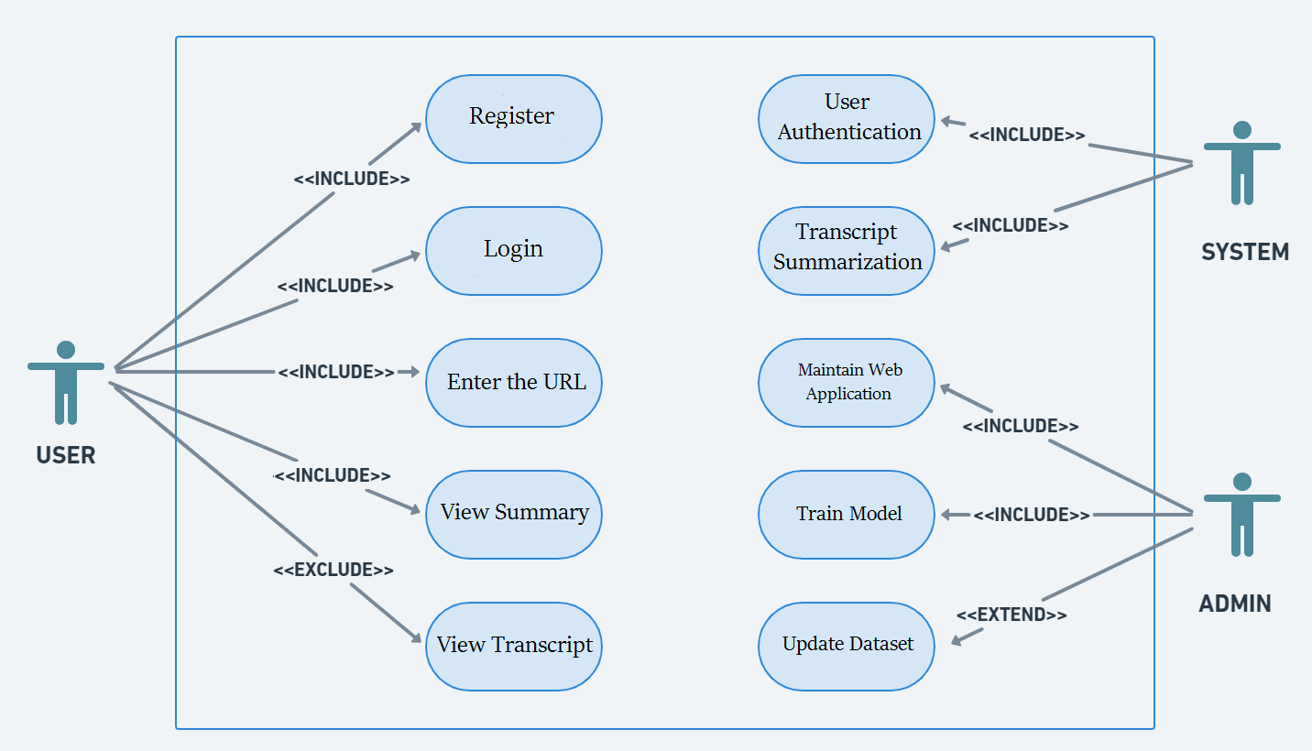
Fig. 2.1 Use-Case diagram

2.5.1 Use-case Descriptions
Title: Forest Fire Prediction
Primary actor: User
Secondary actors: System, Admin
Stakeholders and Interests:
User: Wants to summarise the video. Might be a student, a teacher, a researcher or any other person having access to the system.
System: It is the summarization system which works in the backend when the user enters the video URL for summarizing the video.
Admin: It is the administrator of the system which maintains and updates the system on a frequent basis for improving the efficiency and accuracy of the system. It is the duty of the admin to train the model after updating the dataset and also have to maintain the web application(both frontend and backend).

Chapter 3: Analysis & Conceptual Design & Technical Architecture
3.1 Technical Architecture

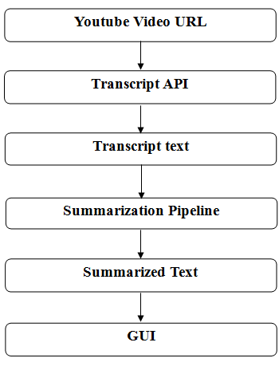
Fig. 3.1 Technical Architecture

3.2 Sequence Diagram
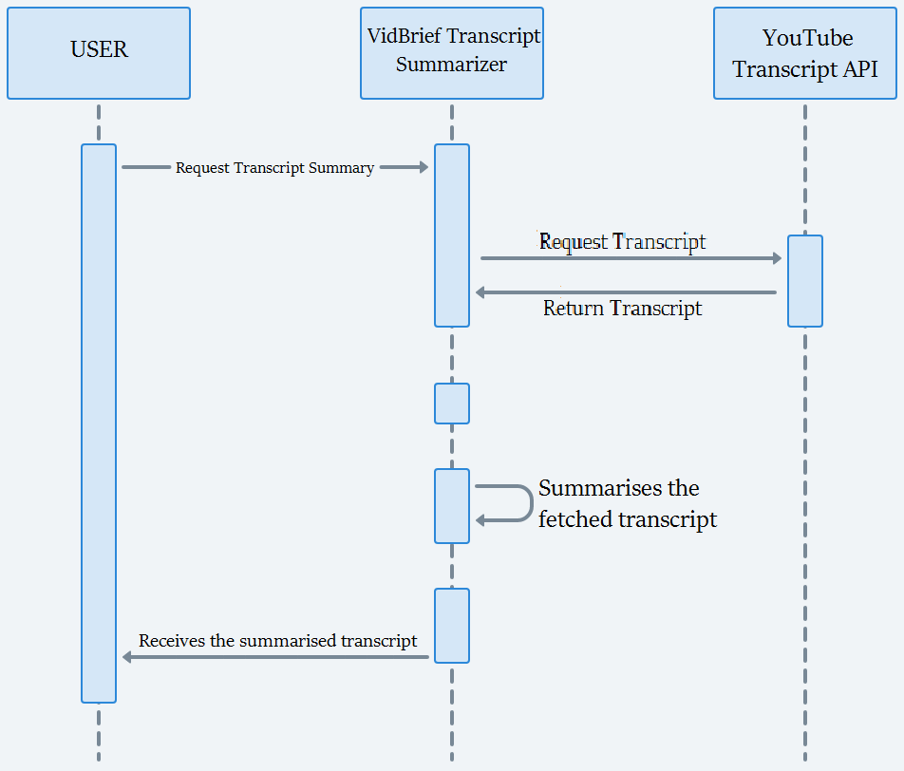
Fig. 3.2 Sequence Diagram

3.3 Class Diagram
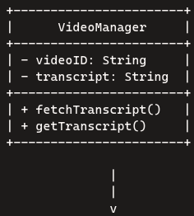
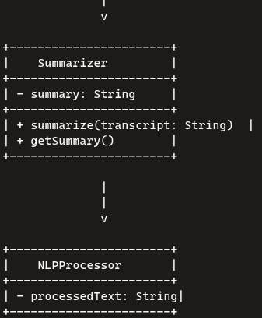
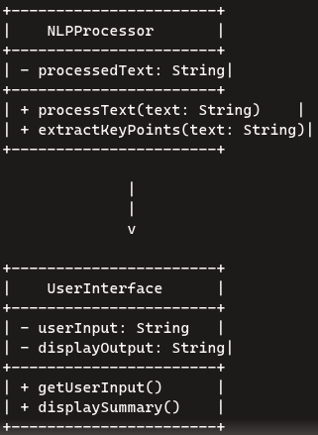
Fig. 3.3 Class Diagram
3.4 DFD

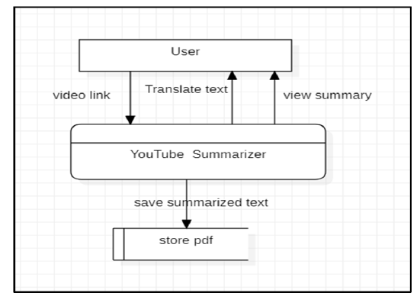
Fig. 3.4 Level-0 DFD
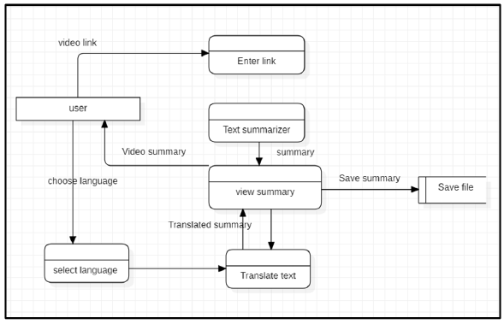
Fig. 3.5 Level-1 DFD

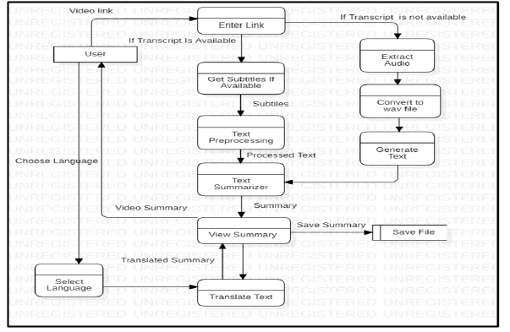
Fig. 3.6 Level-2 DFD

3.5 Data Design
3.5.1 E-R Diagram
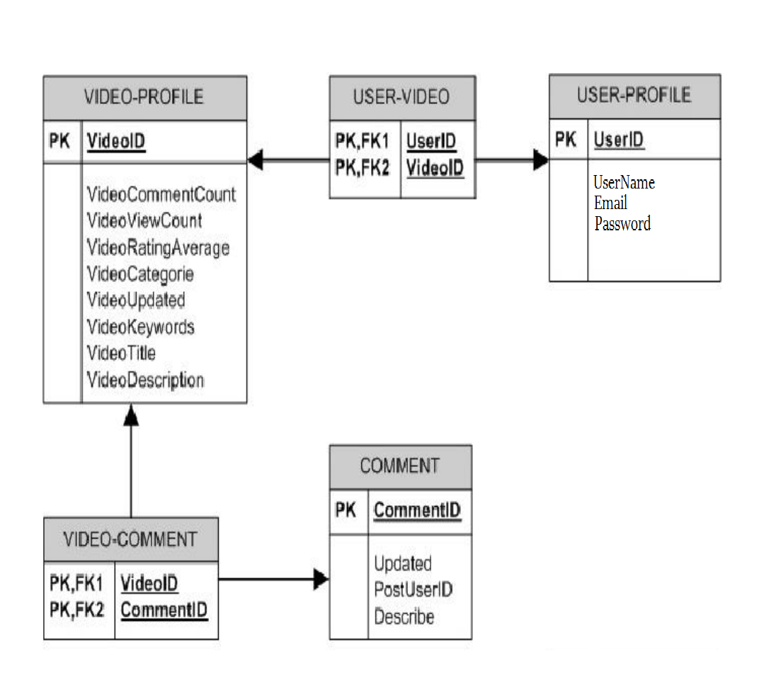
Fig. 8 E-R Diagram

Chapter 4: Implementation & Testing
4.1 Methodology
4.1.1 Proposed Algorithm
1. Input Parameters:
Start with the user entering URL into the system and the maximum length.
2. Standardisation:
To bring uniformity to the features in a dataset by bringing them to a common scale and range.
3. Model Selection:
Select the model appropriate for summarisation tasks. Commonly used models are BART, BERT, Distillbert, T5, etc.
4. Model Training and Testing:
Split the dataset into training and testing sets (e.g., 75% training, 25% testing).
Train the selected model(s) using the training data.
Evaluate the model’s performance using metrics like accuracy, mean squared error, or root mean squared error.
5. Hyperparameter Tuning:
Optimize model hyperparameters to improve performance.
Techniques like RandomSearchCV can help find the best combination of hyperparameters.

6. Validation and Deployment:
Validate the model using the testing set.
Deploy the trained model in a real-time environment (e.g., as part of an early warning system).
Continuously monitor and update the model as new data becomes available.
7. Prediction Output:
The predicted output summary will be displayed to the user on the web application.
4.2 Implementation Approach

4.2.1 Introduction to Languages, IDEs Tools and Technologies
1. Programming Languages:
Python: Python is a popular choice for such projects due to its simplicity and the availability of numerous libraries for image processing, machine learning, and text-to-speech conversion.

2. Integrated Development Environments (IDEs):
PyCharm: PyCharm is a powerful IDE for Python with many useful features like code completion, debugging, testing, and version control integration.
Jupyter Notebook: Jupyter Notebook is a web-based interactive computing environment that allows the creation and sharing of documents that contain live code, equations, visualizations, and narrative text.
Visual Studio Code: Visual Studio Code, often abbreviated as VS Code, is a popular code editor developed by Microsoft. It's highly versatile and customizable, offering support for numerous programming languages and frameworks through its extensive library of extensions.
Google Colab: Google Colab, short for Google Colaboratory, is a free cloud service that allows you to create and share interactive notebooks with code, text, and visualizations. It's particularly popular among data scientists, machine learning engineers, and AI researchers because it provides free access to computing resources like GPUs and TPUs
3. Libraries:
Flask: Flask is a web framework that allows us to build web applications quickly and easily with Flask Libraries. It is basically based on the WSGI toolkit and Jinja2 templating engine. It is used for connecting the frontend part with the backend part.
NumPy: NumPy is a library for the Python programming language, adding support for large, multi-dimensional arrays and matrices, along with a large collection of high-level mathematical functions to operate on these arrays.
Pandas: Pandas is a software library written for the Python programming language for data manipulation and analysis. It enables us to perform tasks such as data cleaning, data transformation, indexing, and aggregation.
Scikit-learn: Scikit-learn (also known as sklearn) is a powerful Python library for machine learning and statistical modeling. It provides a consistent interface for various machine learning tasks, making it easier to implement models in Python.
MySQL Connector-Python: MySQL Connector/Python is a standardized database driver provided by MySQL, allowing Python programs to interact with MySQL databases.
Pickle: The pickle module in Python is used for serializing and de-serializing Python object structures. Pickling is the process of converting a Python object hierarchy into a byte stream. This byte stream can be saved to a file or stored in memory. Essentially, pickling allows you to save Python objects (such as lists, dictionaries, and custom-defined classes) in a format that can be easily restored later.
bz2: The bz2 module in Python provides comprehensive functionality for compressing and decompressing data using the bzip2 compression algorithm.
Transformers: The Transformers library by Hugging Face is a powerful tool for working with state-of-the-art machine learning models in Python. It provides APIs and tools to easily download, train, and use pre-trained models for various tasks across different modalities, such as text, vision, and audio.
NLTK: The Natural Language Toolkit (NLTK) is a powerful library in Python for working with human language data (text). It's widely used for natural language processing (NLP) tasks, offering easy-to-use interfaces to over 50 corpora and lexical resources, along with a suite of text processing libraries for classification, tokenization, stemming, tagging, parsing, and semantic reasoning.
4.3 Testing Approaches
In this section, we will discuss the testing strategies employed to ensure the functionality and reliability of the forest fire prediction system.
4.3.1 Unit Testing
Unit testing is a critical aspect of the development process. It involves testing individual components or units of the tool to ensure they function as expected. This subsection will detail the unit testing approach adopted.
Code Quality: Unit tests help maintain code quality by catching issues early in the development process.
Isolation: Units are tested in isolation, allowing developers to identify and fix problems without affecting other parts of the system.
Regression Prevention: Unit tests run automatically whenever code changes, preventing new code from breaking existing functionality.
4.3.2 Integration Testing
Integration testing evaluates the interactions between different components or modules of the data visualization tool to ensure they work together seamlessly. This subsection will elaborate on the integration testing approach.
Early Issue Detection: Integration testing helps identify and resolve integration issues early in the development process, reducing the risk of more severe problems later on.
Interaction Verification: It confirms that different components work together correctly and exposes any erroneous behavior between two or more units of code.
Risk Reduction: By catching integration issues early, it minimizes the chances of critical failures during system testing or production use.

Chapter 5: Results & Discussion
5.1 User Interface Representation
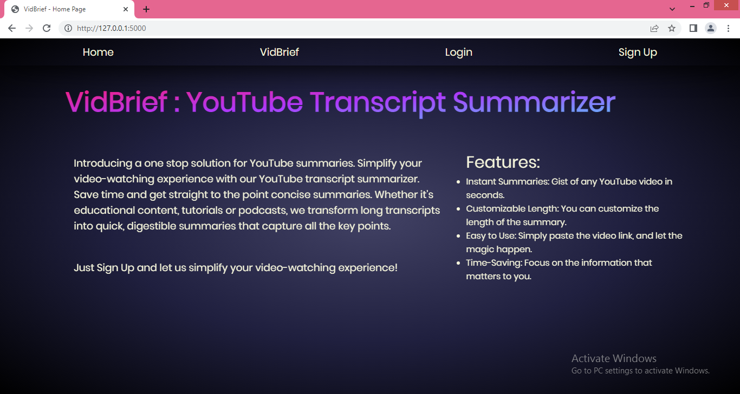
Snapshot 5.1 Home page
5.2 Snapshot of system

Snapshot 5.2 About Page
This is the about page of our system providing information about the need of the project and the existing problem, along with various options for login, signup, and proceeding to the project.
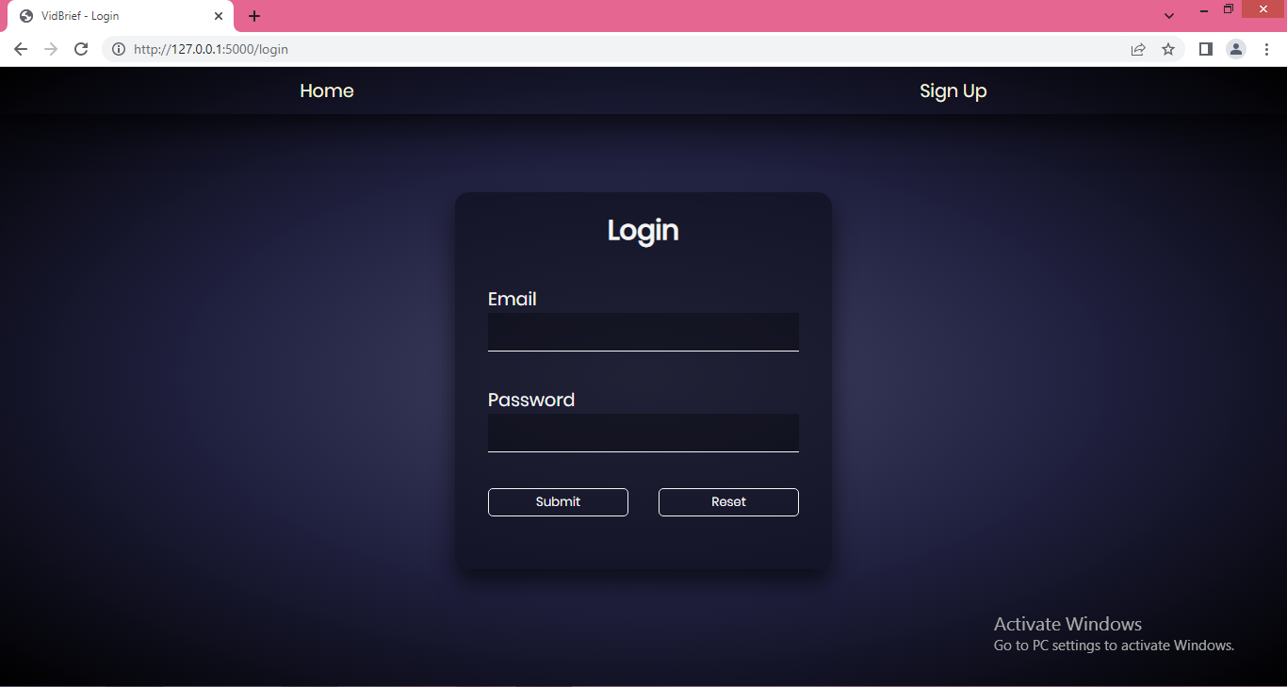
Snapshot 5.3 Login Page
This is the login page of our system where the users who have already signed up on our tool and are ready to use our tool for the fire prediction task.
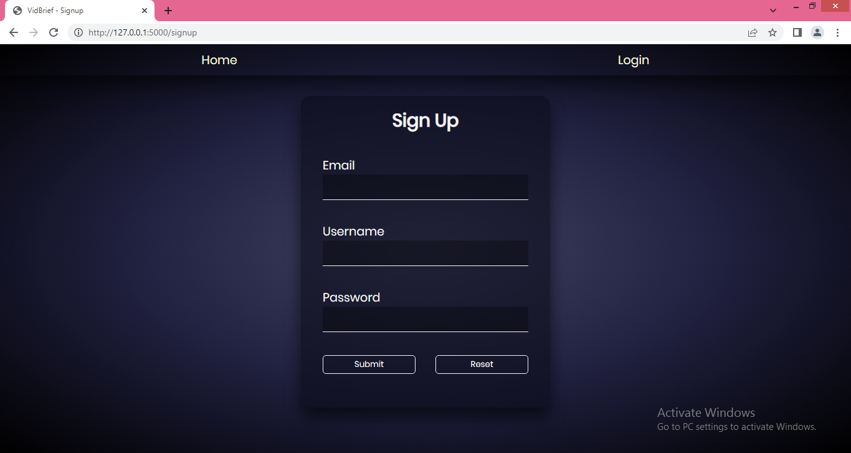
Snapshot 5.4 Sign up Page
This is the signup page for our tool where the new users can signup and use our project for summarization.
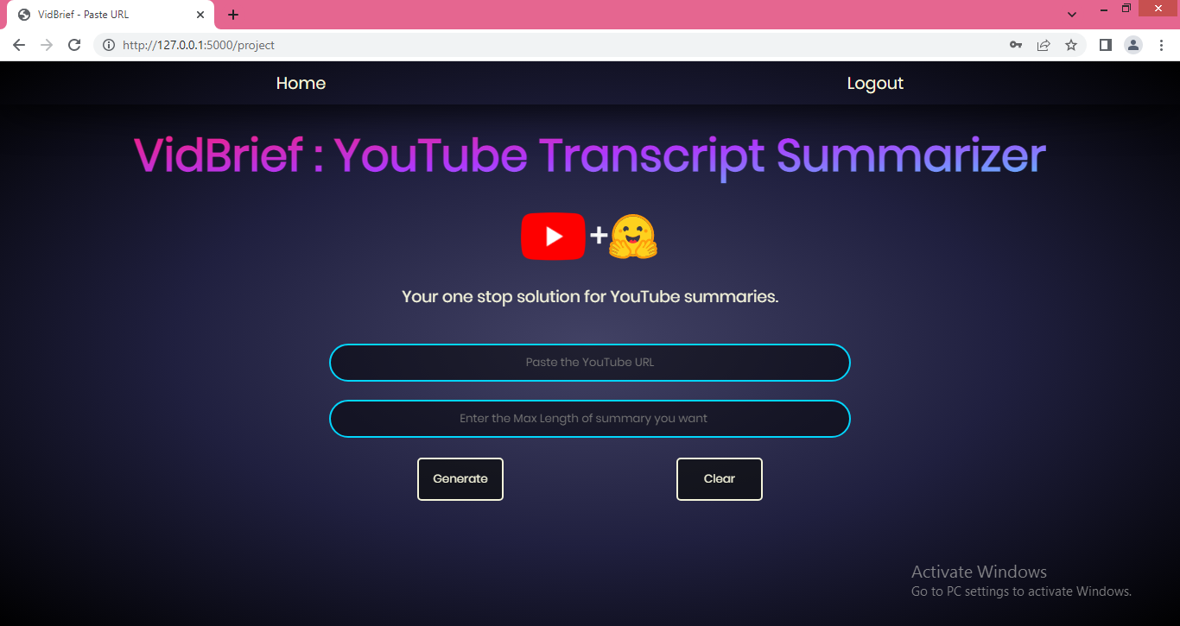
Snapshot 5.5 User Input page
This is the input page of our system where the user can simply input the video URL and get the summary. It consists of two input- one for the URL of the video and the other for required length of the summary.
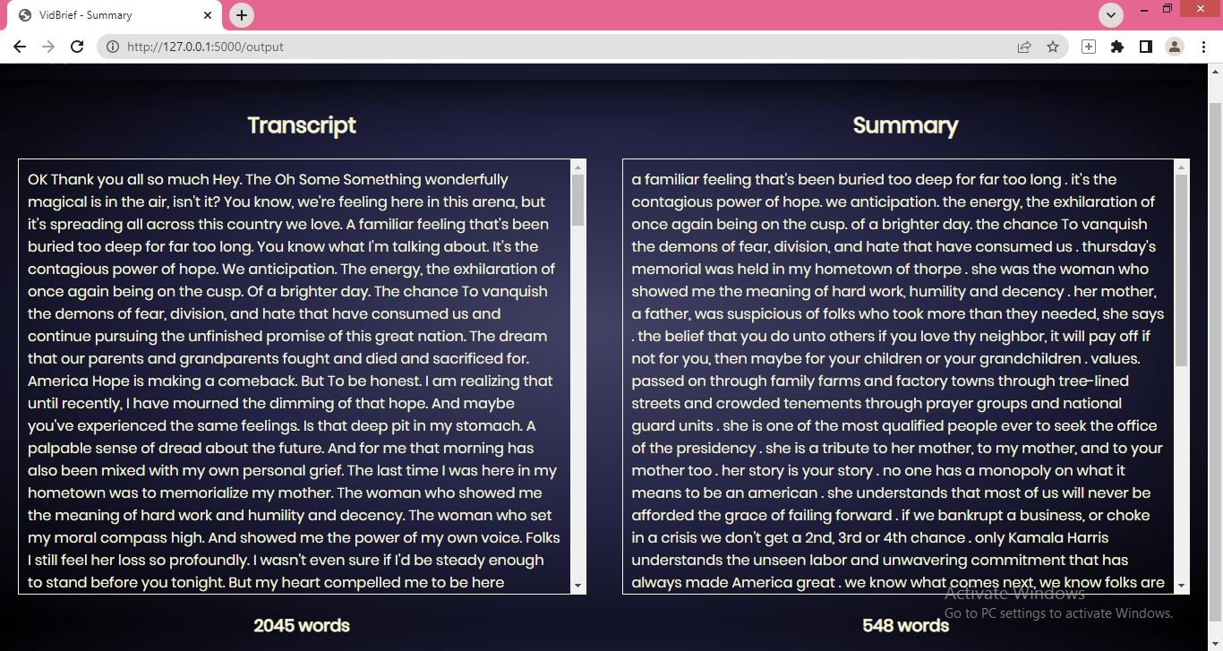
Snapshot 5.6 Output Page
This is the output page of the system where the summarized transcript along with the original transcript is displayed.
5.3 Database Description
5.3.1 Snapshot of database tables with brief description
Snapshot 5.7 Database Tables
This is the snapshot of our database having a table containing the email, username and password of the registered users of our tool. This is made using MySQL Workbench 8.0 CE. The table contains the columns namely ‘id’, ‘username’, ‘email’, ‘password’ of the users used for the validation of the credentials during the login process.
5.4 Final Findings
With the vast amount of video content on YouTube, it can be time-consuming for viewers to sift through long videos to find key information. By summarizing the transcript, the tool helps users quickly understand the main points, topics, or arguments presented in the video. This can be especially useful for educational content, tutorials, lectures, or any informational videos where users want to save time or focus on specific segments. It also improves accessibility for people who prefer reading over watching or those with hearing impairments, offering a text-based way to engage with the content. The purpose of a YouTube transcript summarizer is to help users quickly grasp the main points of a video without having to watch the entire content.
This tool is particularly useful for:
- Saving Time: Users can get the gist of lengthy videos in a fraction of the time.
- Accessibility: It aids those who prefer reading over watching or have hearing impairments.
- Content Review: Content creators and educators can quickly review and edit their videos.
- Efficient Learning: Students and professionals can extract key information from educational and instructional videos.
- Meeting Summaries: Summarize business meetings or webinars to capture essential points.
Overall, it enhances the efficiency and accessibility of consuming video content.

Chapter 6: Conclusion & Future Scope
6.1 Conclusion
The project offers substantial benefits for improving accessibility, efficiency, and engagement with video content. By enabling users to quickly access key insights from videos, the summarizer allows for more efficient content consumption, which is especially valuable given the volume of content uploaded daily. This tool supports users with hearing impairments, and individuals with limited time, making YouTube content more inclusive and user-friendly.
For content creators and marketers, the summarizer provides valuable insights into trending topics and viewer preferences, enabling data-driven strategies and more targeted content planning. Additionally, by optimizing content for search engines with concise summaries, the summarizer enhances discoverability, helping creators reach broader audiences.
However, the project also faces challenges, such as handling transcription errors, ensuring contextual understanding, and addressing technical and ethical limitations. Despite these challenges, advances in natural language processing and machine learning can help address many of these issues, making transcript summarization a promising tool for the future of digital content interaction. Overall, this project is a valuable addition to the content ecosystem, with the potential to make video information more accessible, engaging, and impactful for a global audience.
6.2 Future Scope
The future of YouTube transcript summarization lies in leveraging deep learning, enhancing summarization systems, and fostering interdisciplinary research. Hence, it looks very promising and is likely to evolve significantly.

Educational Use:
- Students and Researchers: A transcript summarizer can help students and researchers quickly review long educational videos, lectures, or webinars by extracting key information. It can condense hours of content into concise summaries, making it easier to study or reference material.
- Online Course Platforms: Integrating the summarizer with online learning platforms (e.g., Coursera, Udemy) can offer students brief summaries of lengthy tutorial or course videos, helping them grasp core concepts faster.
- Quick Revision: Summarized transcripts can be used by students for quick revision, allowing them to revisit the main points of a lecture without rewatching the entire video.

Business and Professional Use:
- Business Meetings and Webinars: Professionals can use a YouTube transcript summarizer to review recorded meetings, webinars, or training sessions. It enables them to extract key takeaways or action points from long discussions without having to rewatch the entire meeting.
- Market Research: Market researchers can use summaries to sift through large amounts of video content to analyze trends, consumer opinions, or competitor strategies efficiently.

Content Marketing and Social Media:
- Video Summaries for Blogs: Video summaries can be repurposed as blog content or social media posts, where users can quickly generate an article-style summary of a video and share it to engage audiences who prefer text-based content.
- SEO and Metadata Generation: A YouTube summarizer can help content marketers generate SEO-friendly descriptions, tags, and metadata based on the summarized content, improving video discoverability.

Content Discovery and Time-saving:
- Video Browsing: Instead of watching long videos to determine their relevance, users can read brief summaries to decide if the video content is worth watching. This is useful for researchers, professionals, and casual viewers alike who want to maximize their time.
- Podcast and Long-Form Content Summaries: For long-format content such as interviews, discussions, or podcasts uploaded to YouTube, summaries provide quick overviews of key points, helping users stay informed without committing extensive time to the entire video.

Personal Productivity:
- Time Management: Busy individuals who want to stay informed can use the summarizer to condense self-help, productivity, or news videos into short summaries that fit into their schedules, allowing them to consume more content in less time.
- Learning on the Go: People can use the summarizer to generate text-based versions of video content that they can read while commuting or multitasking.

Media and Journalism:
- News and Event Summaries: Journalists can use the summarizer to extract the key points from news broadcasts, speeches, or press conferences, allowing them to quickly report or write summaries for articles.

REFERENCES
[1] Jiri Fajtl, Hajar Sadeghi Sokeh, Vasileios Argyriou , Dorothy Monekosso , and PaoloRemagnino: Summarizing Videos with Attention In: Proceedings of the ICLR. Vol. 5(2019).
[2] Kaiyang Zhou, Yu Qiao, Tao Xiang : Deep Reinforcement Learning for UnsupervisedVideo Summarization In: Diversity-Representativeness Reward 2018, Association for theAdvancement of Artificial Intelligence (www.aaai.org).
[3] Mrigank Rochan, Linwei Ye, and Yang Wang: Video Summarization Using FullyConvolutional Sequence Networks In: International Conference on LearningRepresentations (2018).
[4] https://www.crio.do/projects/python-youtube-transcript/
[5] https://pypi.org/project/youtube-transcript-api/
[6]https://www.thepythoncode.com/article/text-summarization-using-huggingface-transformers-python
[7] Ferman A.M. and Tekalp A.M. Two-stage hierarchical video summary extraction tomatch low-level user browsing preerences. IEEE Trans. Multimedia, 5(2):244 – 256, 2003.
[8] P.Sushma, Dr.S.Nagaprasad, Dr. V. Ajantha Devi. Youtube: Bigdata Analytics usingHadoop and Map Reduce in International Journal of Engineering Research in ComputerScience and Engineering (IJERCSE), vol 5, Issue 4, April 2018

